Nem Negash

CMPE 415

Prof. Tinoosh Mohsenin

April 18, 2021

HW6 Report

Problem 1:

1. 100 100 011 010

|  |  |  |  |  |  |  |  |  |  |  |  |  |
| --- | --- | --- | --- | --- | --- | --- | --- | --- | --- | --- | --- | --- |
| Binary Value | 1 | 0 | 0 | 1 | 0 | 0 | 0 | 1 | 1 | 0 | 1 | 0 |
| EEC Code | e12 | e11 | e10 | e9 | e8 | e7 | e6 | e5 | e4 | e3 | e2 | e1 |

e1 = e3 ^ e5 ^ e7 ^ e9 ^ e11 = 0^1^0^1^0 = 0

e2 = e3 ^ e6 ^ e7 ^ e10 ^ e11 = 0^0^0^0^0 = 0

e4 = e5 ^ e6 ^ e7 ^ e12 = 1^0^0^1 = 0

e8 = e9 ^ e10 ^ e11 ^ e12 = 1^0^0^1 = 0

Computed: 0000

Received: 0110

Error Bit Location = computed ^ received = 0000^0110 = 0110 = e6

Corrected Code: 100 100 **1**11 010

1. 000 110 111 000

|  |  |  |  |  |  |  |  |  |  |  |  |  |
| --- | --- | --- | --- | --- | --- | --- | --- | --- | --- | --- | --- | --- |
| Binary Value | 0 | 0 | 0 | 1 | 1 | 0 | 1 | 1 | 1 | 0 | 0 | 0 |
| EEC Code | e12 | e11 | e10 | e9 | e8 | e7 | e6 | e5 | e4 | e3 | e2 | e1 |

e1 = e3 ^ e5 ^ e7 ^ e9 ^ e11 = 0^1^0^1^0 = 0

e2 = e3 ^ e6 ^ e7 ^ e10 ^ e11 = 0^1^0^0^0 = 1

e4 = e5 ^ e6 ^ e7 ^ e12 = 1^1^0^0 = 0

e8 = e9 ^ e10 ^ e11 ^ e12 = 1^0^0^0 = 1

Computed: 1010

Received: 1100

Error Bit Location = computed ^ received = 1010 ^1100 = 0110 = e6

Corrected Code: 000 110 **0**11 000

1. 111 011 011 101

|  |  |  |  |  |  |  |  |  |  |  |  |  |
| --- | --- | --- | --- | --- | --- | --- | --- | --- | --- | --- | --- | --- |
| Binary Value | 1 | 1 | 1 | 0 | 1 | 1 | 0 | 1 | 1 | 1 | 0 | 1 |
| EEC Code | e12 | e11 | e10 | e9 | e8 | e7 | e6 | e5 | e4 | e3 | e2 | e1 |

e1 = e3 ^ e5 ^ e7 ^ e9 ^ e11 = 1^1^1^0^1 = 0

e2 = e3 ^ e6 ^ e7 ^ e10 ^ e11 = 1^0^1^1^1 = 0

e4 = e5 ^ e6 ^ e7 ^ e12 = 1^0^1^1 = 1

e8 = e9 ^ e10 ^ e11 ^ e12 = 0^1^1^1= 1

Computed: 1100

Received: 1101

Error Bit Location = computed ^ received = 1100 ^ 1101 = 0001 = e1

Corrected Code: 111 011 011 10**0**

Problem 2:

[5 pts] What is the length of total code word? Which bits are check bits and which one are data bits? Compute the ECC bits for 4-bit data 0110 and write the complete code word.

|  |  |  |  |  |  |  |
| --- | --- | --- | --- | --- | --- | --- |
| D4 | D3 | D2 | E4 | D1 | E2 | E1 |

|  |  |  |  |  |  |  |  |
| --- | --- | --- | --- | --- | --- | --- | --- |
| Bit_position | 7 | 6 | 5 | 4 | 3 | 2 | 1 |
| Bits | 0 | 1 | 1 | E4 | 0 | E2 | E1 |

e1 = d3 ^ d5 ^ d7 = 0^1^0 = 1

e2 = d3 ^ d6 ^ d7 = 0^1^0 = 1

e4 = d5 ^ d6 ^ d7 = 1^1^0 = 0

|  |  |  |  |  |  |  |  |
| --- | --- | --- | --- | --- | --- | --- | --- |
| Bit_position | 7 | 6 | 5 | 4 | 3 | 2 | 1 |
| Bits | 0 | 1 | 1 | 0 | 0 | 1 | 1 |

Complete Code word = 0110011.

[20 pts] Write the verilog for the module that checks if there is an error in the received data. The verilog module has the received word as input and has two outputs error and error-bit. If there is any error, then the verilog module must locate the error bit and make the error signal to be 1 and send out the location of error-bit. Otherwise the error signal remains zero.

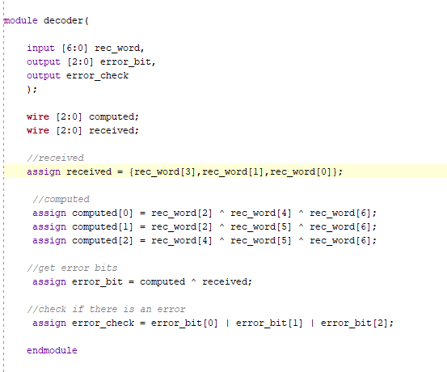

[15 pt] Write a testbench that can test the block with these input values. First write down what is the error bit location if there was an error.

o 1111000

o 0110111

o 1000111

o 0111010

